Exam 1 Review

Table of Contents

Notes from Instructor 3

Topics 3

PowerPoint Review 4

Ch1- Intro 4

1-15 Intro 4

16-33 What is AI? 4

34-36 Foundations 4

37-38 History 4

39-49 State of the art 4

50-51 Summary 4

Ch2 – Intelligent Agents 5

1-4 Intro 5

5-17 Agents and Environments 5

18-38 Good Behavior 5

39-58 Nature of Environments 5

59-117 Structure of Agents 5

Ch3- Solving by searching 6

1-7 Intro 6

8-20 Problem Solving Agents 6

21-38 Example Problems 6

39-50 Searching for Solutions 6

51-68 Uninformed Search Strategies 6

69-99 Informed Search Strategies 6

99-103 Heuristic Functions 6

Ch4- Beyond Classical Search 7

1-4 Intro 7

5-31 Local Search Algorithms and Optimization Problems 7

32-36 Logical Search in Continuous Space 7

37-49 Searching with Non-Deterministic Actions 7

50-63 Searching with Partial Observations 7

# Notes from Instructor

# Topics

CH1

Place the 5 phases of AI in chronological order

Discussion about state of the art

Chapter summary

CH2

agents

the basic agent functions

good behavior

rationality

PEAS

Describe internal structure of 4 agents at a high level

Representing states

atomic

vector...

CH3

well defined problems

toy problems

path cost

real world problems

Search

tree search

infrastructure for search

what data structures

state

parent

action

path cost

Evaluation

completeness

optimality

Uninformed Search

Depth-First Search (DFS)

counterclockwise traversal around perimeter "around the tree"

Depth-Limited Search (DLS)

counterclockwise traversal, one level at a time, around perimeter "around the tree"

Iterative Deepening Search (IDS)

Bidirectional Search

Informed Search

Be able to work out given problems

Greedy Best-First Search

A*

Recursive Best-First Search (RBFS)

Questions about

Memory Bounded A* (MA*)

Simplified Memory Bounded A* (SMA*)

Heuristic Functions

properties

valid heuristics can never overestimate

CH4

local search

hill climb

simulated annealing

beam search

hill climb with agents in parallel

size of beam is number of agents

genetic algorithms

naive - 2 parents

breeding population

complicating the search

searching without percepts

searching with non-deterministic actions

searching with percepts AND non-determinism

in the vacuum cleaner world is it possible to search with non-determinism and guarantee

completeness?

optimality?

CH5

minimax

alpha-beta pruning

search vs lookup

lookup for first 4 moves of chess

then switch to search

partially observable

cards

state of the art games

questions only

mostly deep learning

Question 5

{node}, f = cost{ToNode} + h{node}

{s} f = 0 + 7

{s,a} f = 1 + 6

{s,b} f = 4 + 2

Draw minimax search tree

be able to alpha-beta prune a tree, simply circling the node

# PowerPoint Review

## Ch1- Intro

51 Slides

### 1-15 Intro

### 16-33 What is AI?

|  |  |  |
| --- | --- | --- |
|  | Humanly | Rational |
| Thinking | * Machines with minds * decision making * problem solving/ learning | * Models of mental faculties |
| Acting | * Making computers do things, at which the moment, humans are better | * Inteligent agents |

#### Acting Humanly

#### NLP - natural language processing for communication

#### Knowledge Representation - to store what it knows or hears

#### Automated reasoning - use stored information to answer questions or draw new conclusions

#### Machine learning – adapt to new circumstances

#### Computer Vision - perceive objects

#### Robotics - manipulate objects

#### Three ways to achieve thinking humanly:

#### through introspection—trying to catch our own thoughts as they go by;

#### through psychological experiments—observing a person in action; and

#### through brain imaging—observing the brain in action.

#### Thinking Rationally

#### Aristotle and his syllogisms provided template for “right thinking”

#### Acting Rationally

#### Agent – something that does or acts

Rational agent – acts or does to achieve a measurable outcome

### 34-36 Foundations

### 37-38 History

### 39-49 State of the art

### 50-51 Summary

#### The chart above shows the distinctions of the different branches of AI

#### Thinking vs behavior

#### Human vs ideal standard

#### Ration action is the focus of the course

## Ch2 – Intelligent Agents

117 Slides

### 1-4 Intro

### 5-17 Agents and Environments

#### Agent – anything that perceives its environment through sensors

#### Percept – refers to the agent’s perceptual inputs at any given instant

#### Percept sequence- complete history of everything agent has perceived

#### Agent function – maps any given percept sequence to an action in terms of a mathematical expression

#### **/\ and \/ These two definitions sound similar, but are important to distinguish**

#### Agent program – concrete implementation, running within a physical system

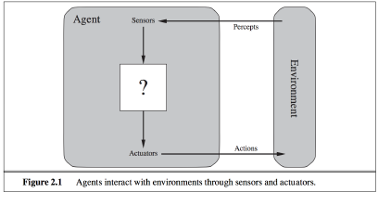

#### human agent

#### **has:**

#### eyes, ears, and other organs for sensors and

#### hands, legs, vocal tract, and so on for actuators.

#### robotic agent

#### **might have:**

#### cameras and infrared range finders for

#### sensors and various motors for actuators.

#### A software agent

#### **Receives:**

#### keystrokes, file contents, and network

#### packets as sensory inputs

#### **acts on the environment by:**

#### displaying on the screen, writing files, and sending network

#### packets.

### 18-38 Good Behavior

#### Good behavior is determined by how well the agent performs

#### Measurement occurs:

#### 1 from the reference frame of the environment state

#### 2 what one wants in the environment

#### Rational Agent criteria

#### 1 performance measure

#### 2 agents’ prior knowledge

#### 3 actions availed

#### 4 percept sequence to data

#### Omniscience, Learning and Autonomy

Omniscience- knowing the outcome of all given actions

#### Rationality - is not perfection because most complex environments will have some degree of chaos

#### Information gathering:

#### 1 performing actions to modify future percepts

#### 2 exploring

Autonomy – the extent to which an agent relies on the knowledge of its designer rather than it’s own percepts

### 39-58 Nature of Environments

PEAS- dimensions of task environments

Performance, Environment, Actuators, Sensors

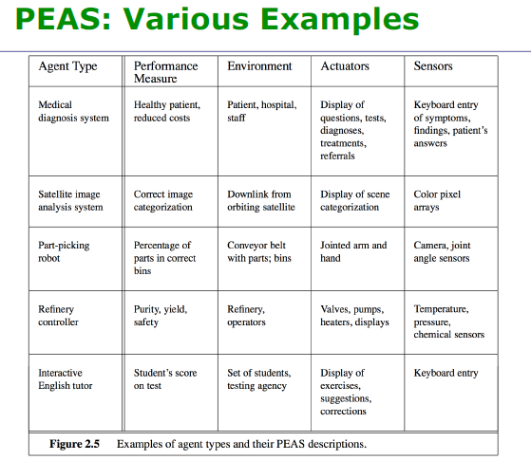

Properties of Task Environments

* + - the hardness is not in order of priority,
    - THE ENVIRONMENT determines which property would be the hardest

|  |  |  |  |  |  |
| --- | --- | --- | --- | --- | --- |
|  | Def | Reason | Pros | Cons | Hard |
| Fully observable | sensors give full env state | sensors obsv all aspects relevant to actions | agent needs less memory |  |  |
| Partially observable | sensors don’t give full env state | noisy env, inaccurate sensors | agent needs less sensors | agent can’t discover itself in env | X |
| Single Agent | one agent only | the agent is alone | simple perf measure |  |  |
| Multiagent | B's perf measure depends on A's | one agent affects another |  | complex perf measure | X |
| Deterministic | next STATE is determined by current | states are fixed | a solution can be reached |  |  |
| Stochastic | next STATE independent from current | states are variable |  | solution not guaranteed | X |
| Episodic | 1 action per episode.  Episode independent of each other | agents experience is based on pattern |  |  |  |
| Sequential | actions effect future decisions | agents experience is based on decisions |  | solution not guaranteed | X |
| Static | env stays stationary until agent acts | environment is fixed with time |  |  |  |
| Dynamic | env change while agent thinks | environment is variable with time |  |  | X |
| Discrete | finite state, finite time, finite percepts and actions |  | processing time irrelevant |  |  |
| Continuous | many states, infinite time, infinite percepts and actions |  |  | time it takes to find solution might miss it | X |
| Known | designer knows all outcomes.  Agent is programed with them |  | solution can be reached |  |  |
| Unknown | design does not know outcomes.  Agent must learn |  |  | agent might not learn enough | X |

Know how to use the task Environment Assessment Below

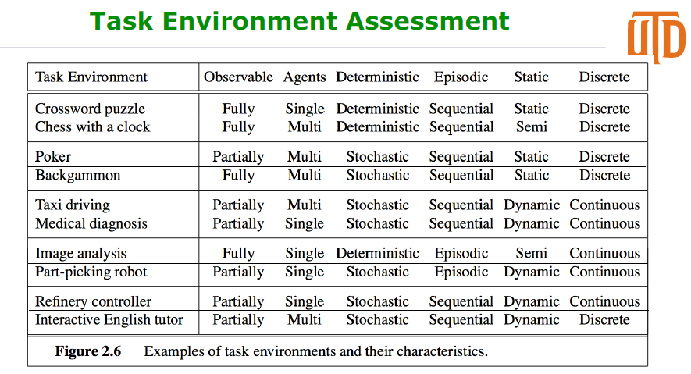

Random Combinations of Task Environment Properties from slides

|  |  |  |
| --- | --- | --- |
| Combinations |  |  |
| uncertain | partial observable + stochastic |  |
| nondeterministic | actions characterized by possible outcomes | the next STATE is determined by current with a degree of likelihood |
| semi dynamic | static env, agent's perf measure drops with time | limited states and percepts, but time to make decision drops agents score |

### 59-117 Structure of Agents

Agent program – current percept only

Agent function – might contain the entire percept history, some functions ignore the history

Agent – contains both the program and function

Agent Chart Breakdown

|  |  |  |  |  |  |
| --- | --- | --- | --- | --- | --- |
|  | Percept History | How does it work | “What is the world like now?” | “What action should I do now?” | “What do my actions do?” |
| Simple reflex |  | general purpose interpreter for condition-action rules. Combine with a rule set | Sensors | Condition-action rules | doesn't matter |
| Model based reflex | X | 1) agent needs to know how world evolves independently of agent.  2) Agent needs to know how its actions affect the world | 1 Sensors  2 How the world evolves  3 What my actions do | Condition-action rules | They effect the world AND the model of the world, internal to the agent |
| Goal based | X | 1) Model reflex  2) with action sequences created from searching and planning | 1 Sensors  2 How the world evolves  3 What my actions do | Goals | They effect the world AND the likelihood of reaching the goal |
| Utility Based | X | 1) Resolve conflicting goals with utility ranking.  2) Account for uncertainty of each goal, and end result with be a combination of highest utility and highest likelihood of success | 1 Sensors  2 How the world evolves  3 What my actions do | One with the highest utility and lowest failure rate | They effect the world AND my happiness level |
| Learning Agents | X |  |  |  |  |

Atomic

States are Indivisible

No internal structure

States are independent black box's

Search and gameplay, Markov,

Factored

Each state in split up into variables

Variables may be common between some states

Constraint satisfaction/propositional logic/ planning / Bayesian networks/ deep learning

Structured

States include objects that may have relations to other objects in the state

Relational databases / first order logic and probability models / natural language processing

## Ch3- Solving by searching

103 Slides

### 1-7 Intro

### 8-20 Problem Solving Agents

### 21-38 Example Problems

### 39-50 Searching for Solutions

### 51-68 Uninformed Search Strategies

### 69-99 Informed Search Strategies

### 99-103 Heuristic Functions

### 

## Ch4- Beyond Classical Search

63 Slides

### 1-4 Intro

### 5-31 Local Search Algorithms and Optimization Problems

### 32-36 Logical Search in Continuous Space

### 37-49 Searching with Non-Deterministic Actions

### 50-63 Searching with Partial Observations